Essay on Solving Intersection and Area Problems Using Python

Introduction
In this report, we will see how programmatically we solve the mathematical problem of finding the intersection points and the areas under and between a curve and a line. The primary objectives were to determine the intersection of the curve (y = 5 + 4x - x^2) and the line (y = 10 - 2x), compute the area under both the curve and the line, and finally find the area between them. This problem was addressed using Python libraries such as NumPy, SymPy, and Matplotlib for numerical operations, symbolic mathematics, and visualization, respectively.

Code Explanation
The main function “graph()” takes two lambda functions representing the equations and a range of x-values as inputs. This function visualizes the equations on the same plot, finds their intersection points, and calculates the areas under the curve and the line.
- Finding Intersection Points
The intersection points are determined by equating the two equations and solving for x. This was accomplished using SymPy's symbolic equation solving capabilities:
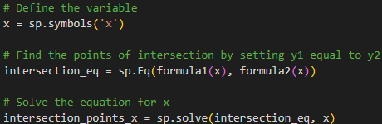
The corresponding y-values are then calculated using one of the equations.
- Calculating Area Under the Curve
The area under the curve (y = 5 + 4x - x^2) was calculated using the Trapezoidal Rule. This is implemented in the function “area_curve()”, which takes the x-values of the intersections and evaluates the integral numerically:
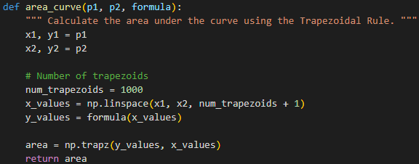

- Calculating Area Under the Line
The area under the line (y = 10 - 2x) was calculated using the Trapezoidal Rule. This is implemented in the function “area_curve()”, which takes the x-values of the intersections and evaluates the integral numerically:
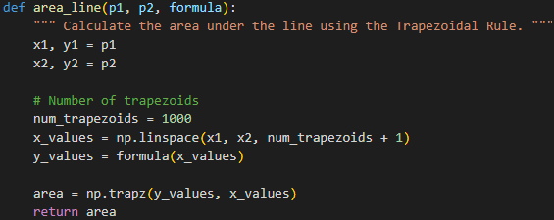

- Finding Area Between the Curve and the Line
The final step involves subtracting the area under the line from the area under the curve, thereby yielding the area between the two. This was efficiently handled by the code using a simple subtraction operation:

Alternative Approach
An alternative approach could involve using analytical methods to solve the integrals for areas under the curve and line or we can use different python libraries like Scipy numerical integration method “scipy.integrate.quad” or we can use Riemann Sums/Rectangle Method, where we need to provide manual implementation without any python libraries.
For plotting we can use different python libraries like seaborn, plotty and more.

References
Asutkar, S. (n.d.). A Step-by-Step Guide to the Trapezoidal Rule. Retrieved from askpython.com: https://www.askpython.com/python-modules/numpy/numpy-trapz
Learning, G. (n.d.). SIG742 - Modern Data Science. Retrieved from olympus.mygreatlearning.com: https://olympus.mygreatlearning.com/courses/103477
Sharma, R. (n.d.). Introduction to SymPy for Symbolic Mathematics. Retrieved from medium.com: https://medium.com/pythoneers/introduction-to-sympy-for-symbolic-mathematics-d03788f2fc15

Conclusion
The code implemented successfully addresses the problem of finding intersections and areas related to a curve and a line. The numerical approach adopted using Python provides a flexible and efficient solution, easily adaptable for different functions and ranges. Understanding these fundamental mathematical operations and their implementation in programming is essential for tackling various applied mathematics and engineering problems. Future work could explore using different numerical methods or extending the solution to handle 3D surfaces and their intersections.

